**SURGEM-III user’s guide**

Jan 25, 2012

**To load the model**

To **load** the Heart model, press ‘g’. After that, you can load other models (press ‘G’)

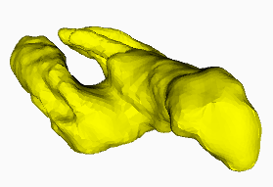

**To change the view**

To rotate the view around the focus point, press&drag the mouse. To change the focus point, position the mouse over the surface, then press and release ‘.’ without pressing the mouse button. The view will change to put the focus point at the center. To set the focus point to the center of the box of the object, press and release ‘]’

To zoom (move model closer/further), keep ’z’ pressed and press&drag the mouse vertically. If you also drag the mouse horizontally, you rotate around the viewing direction. Holding ‘Z’ instead, locks the orientation.

To save the current view, press ‘j’. To restore the saved view, press ‘J’. To reset the view, press ‘;’.

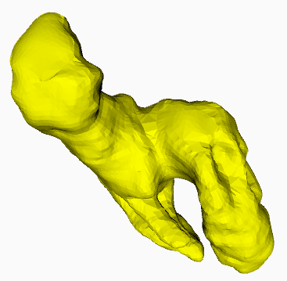

**To create and edit the cut curve**

To design a new curve, press ‘e’ to **erase** the previous one (if you had one) and set a nice view. Keep ‘a’ pressed and click the mouse at consecutive control points that you want the cut curve to traverse. At each click, a new control point is **appended** to the cut curve. If you want to continue around the object, you can of course release ‘a’, click&drag the mouse to rotate, then press ‘a’ and continue adding the points. But, it may be easier to keep the same view, but to press ‘b’ to indicate that you will be adding points on the back. Then, keep ‘a’ pressed and continue clicking to add points in order around the shape. Then, press ‘f’ to indicate that you will now be working on the front part. SURGEM-III shows a smooth interpolation of the control points, which are identified by small balls. The first control point is red. The hidden part of the curve is shown as if with x-ray vision, so it is best to rotate the view a bit back & forth to understand where the cut curve is in 3D.

To edit the curve, you can at any time use ‘’b and ‘f’ to select whether you want to edit points on the front part or on the back part. To **tweak** the location of control points, keep ‘t’ pressed, and press&drag the mouse near a control point to change its location. Make sure that the mouse stays on top of the surface. You can keep ‘t’ pressed and edit several control points like this. Keeping ‘i’ pressed, you can **insert** a new control point after a control point by a click&drag on that control point. Keeping ‘x’ pressed and clicking on control points will **delete** them.

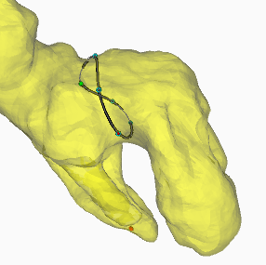

You can show/hide the **ribs** (as orange lines) on the baffle by pressing ‘B’. To rotate their **orientation**, keep ‘r’ pressed and slide the mouse horizontally (without pressing it).

To **save** the cut curve on file, press ‘w’. It is a good idea to do this during editing, in case something goes wrong. You can **load** a saved cut curve by pressing ‘l’.

**To perform the surgery**

Press ‘C’ to perform the virtual **surgery**. If things go well, the cut curve splits the heart surface in two parts, one shown in yellow (part number 0), the other one in green (part number 2). Both are closed meshes obtained by stitching them with their copy of the baffle, along a version of cut curve obtained by projecting it onto the heart surface. You can use the menu to **export** these two models into separate files.

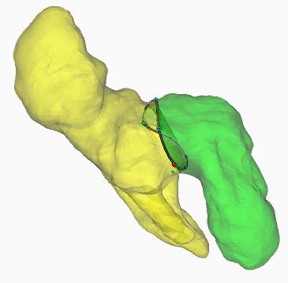 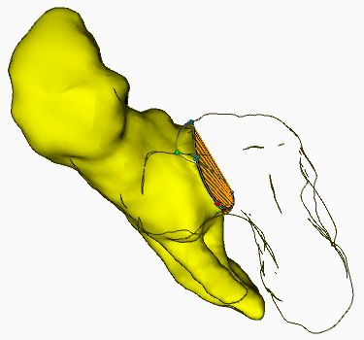 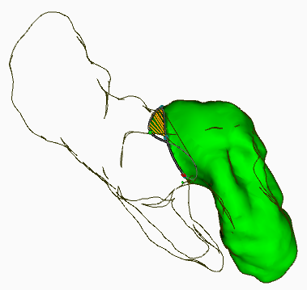

SURGEM-III will display the **volumes** in ml and the percentages of the total volume of each part.

You can edit the cut curve as explained above (using ‘t’, ‘i’, ‘b’/’f’) and then perform the operation again by pressing ‘C’. You can also press ‘U’ to undo the previous surgery so that you see only one yellow part.

**To measure the mesh**

After you have performed the virtual surgery, keep ‘h’ pressed and move the mouse over the shape without pressing the mouse button. If you move over part 0 (yellow), SURGEM-III will show (red line) and print the distance to the part 2 (green), and vice versa.

**To change the visualization**

You can **hide/show** each part by pressing ‘0’ or ‘2’. You can change the display style in several ways. ‘_’ will toggle between flat shading and **smooth** shading. ‘=’ turns on/off the **transparent** mode. In transparent mode, when a part is not shown, its back faces are shown in transparent grey. Pressing ‘S’ turns on/off the display of **silhouette** edges, which provide some useful visual hints. When not in transparent mode, pressing ‘H’ will turn on/off the display of the **hidden** (back) faces. These are useful to see the heart from the interior, either by zooming in, so that the front part is clipped, or by hiding a part (press ‘0’ or ‘2’).

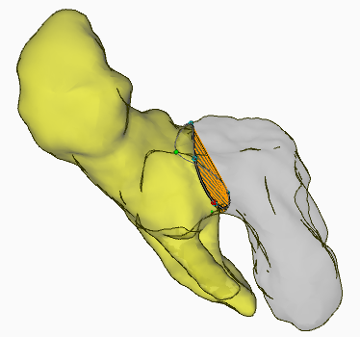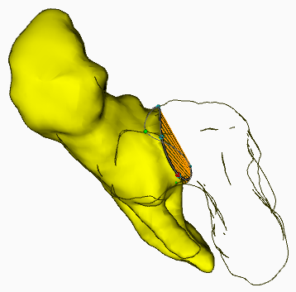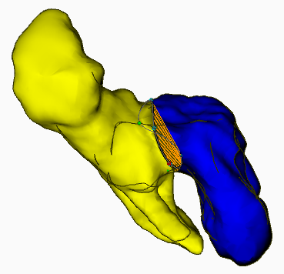

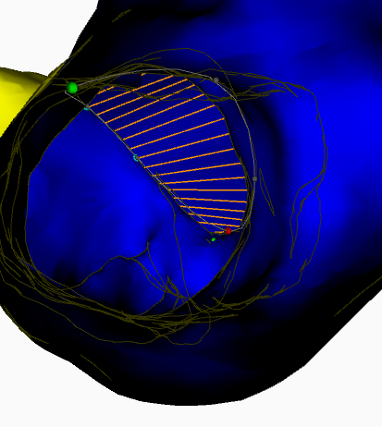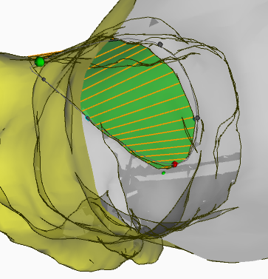

**To draw the baffle cutout**

You can see a drawing of the flattened baffle by pressing ‘+’. Pressing it again will return to the 3D view. The flat baffle is drawn over a green grid of 1 cm. Red lines are drawn to show the border of the flattened baffle that should be used. SURGEM-III computes and shows the smallest sufficient diameter (in multiples of 2 mm). The control points that you have used are shown along the border. The first one is shown in red.

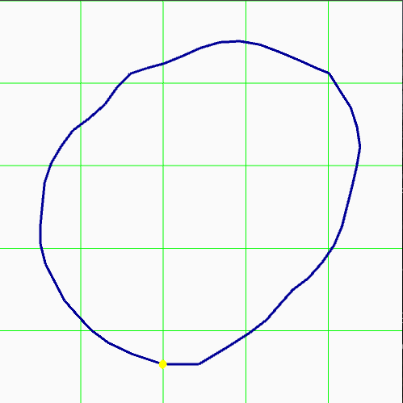

**To exit**

Make sure that you have saved the cut and exported the two parts. To exit press ‘Q’.